Registration Guidelines of Chinese Proficiency Test Level 3 for ECNU oversee students
《国际汉语能力标准》三级水平考试报名操作流程

Log in to ECNU system(公共数据库）
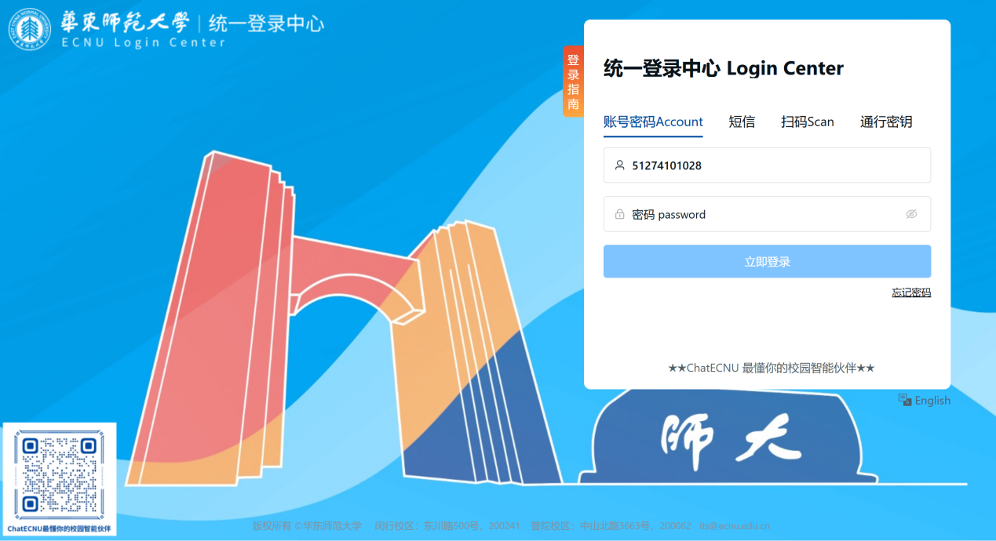

➩Click Education and Teaching Management Platform（教育教学管理平台）
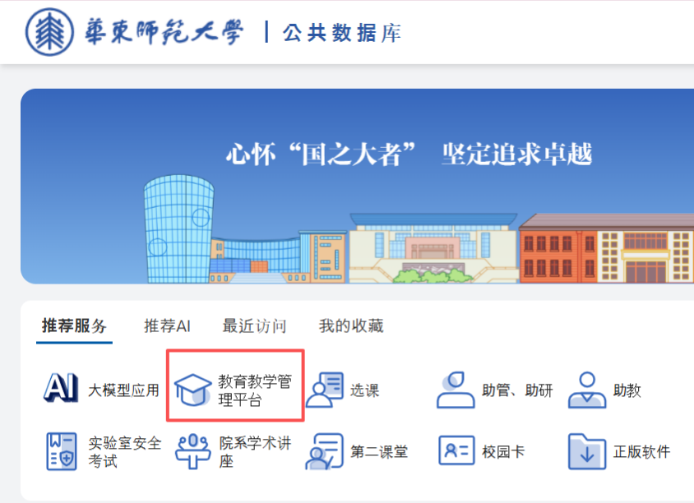
➩Click Comprehensive Services Module（综合服务）-Registration of Chinese Proficiency Test Level 3 for ECNU oversee students(留学生汉语三级水平校内考试报名）

➩You’ll see the “sign in”button when specified open registration period
在报名开放时间内，可查看“可报名”的考试信息

➩Once you have completed the registration, you will be able to check the detailed information of the exam.
点击【报名】。报名成功后，可以看到具体的考试信息
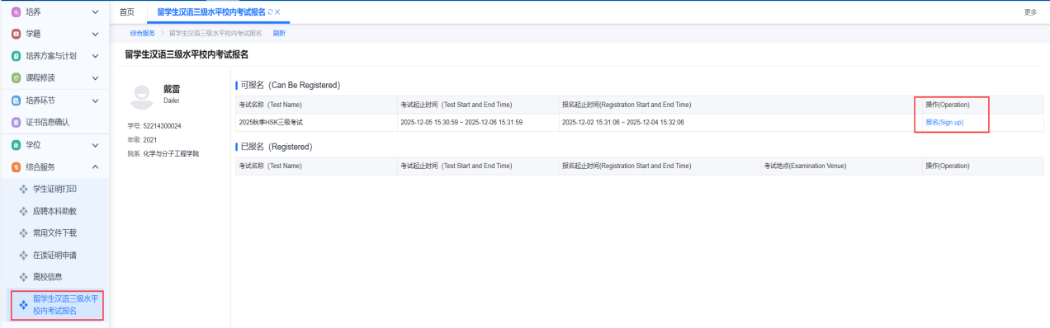

➩You may cancel this registration by clicking the “Cancel” (取消报名）button.
点击【取消报名】可以取消本次报名
